Name __________________________________________________ Date ___________Period/Section____
Chapter 9-1 Taking Notes
Directions- Use what you have read about popes and rulers in section 1 to fill out the diagram. You may use you own sheet of paper. Please write three facts per head piece. Don’t forget to answer the three questions at the bottom of the page.
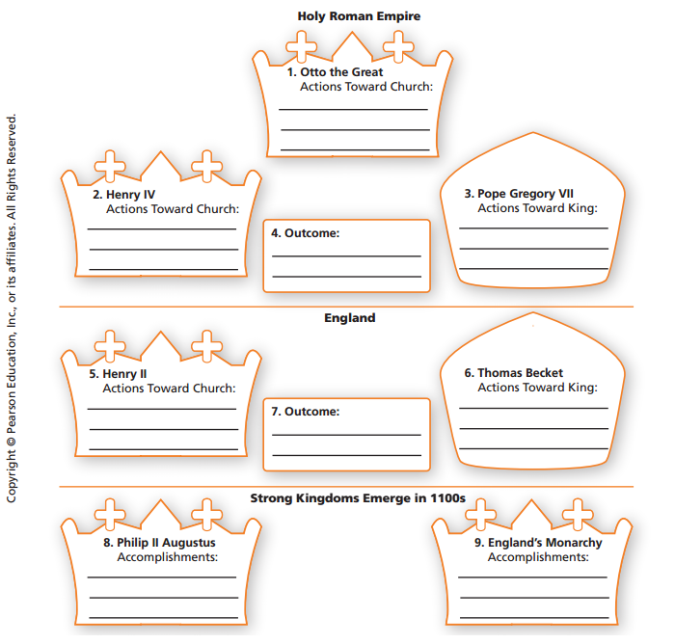
Answer the following questions in complete sentences and using your own words.
10. Define excommunication.
11. Use the chart on page 282 to answer this question. Describe the structure of the Medieval Church. In which ways was the church hierarchy like the feudal system? Remember, this is a two part question.
12. What mistakes did Henry II make in his conflict with the Church?

