Melanie Werner
Seymour Middle School

DBQ: The Tale of Genji
Standards
- 7.29 Trace the emergence of the Japanese nation during the Nara, 710-794, and the Heian periods, 794-1180. (H,P)
- 7.30 Describe how the Heian (contemporary Kyoto) aristocracy created enduring Japanese cultural perspectives that are epitomized in works or prose such as The Tale of Genji, one of the world’s first novels. (C, H)
Objectives
- Identify Murasaki Shikibu and explain the importance of The Tale of the Genji.
- Explain how The Tale of the Genji fits into the Heian period.
Materials
- The Tale of Genji worksheet with quotes and questions.
Time Needed
- One 45 class period. Additional time may be needed to finish questions or to review the answers to the questions.
Focus/Hook
- “What are some example of popular books? Have you ever thought about the first novel? What does the type of literature say about our culture? Discuss these questions as a class.
Lesson-
- “Today we are going to read excerpts from the world’s first novel, The Tale of Genji.”
- “First, we will visit The Tale of Genji Museum where we will read an introduction to this tale and an introduction to the author, Murasaki Shikibu.”
- Visit The Tale of Genji Museum website at http://www.uji-genji.jp/en/genji/. This is the introduction page. Read the introduction to The Tale of Genji, The Tale of Genji and Uri City, and Murasaki Shikibu.
Assessment
- Students will then get into groups of two or three. In these groups they will answer questions based on the novel or art associated with the novel.
- When students have finished, go over each passage and explain how each passages relates to the Heian period.
Background knowledge for teachers
- Information on the novel-
  - Arntzen, Sonja. "The Heart of History: The Tale of Genji." Education About Asia. Association for Asian Studies, 1 Jan. 2005. Web. 1 Mar. 2015. <https://www.asian-studies.org/EAA/EAA-Archives/10/3/640.pdf>.
- Information on the Heian Period-
  - Verner, Melinda. "Teaching about Heian Japan." Education About Asia. Association for Asian Studies, 1 Jan. 2005. Web. 1 Mar. 2015. <https://www.asian-studies.org/EAA/EAA-Archives/10/3/639.pdf>.
- This video gets a general overview of The Tale of Genji. This video is not suitable for students to watch. However; small excerpts could be taken out to show students.
  - http://www.learner.org/courses/worldlit/the-tale-of-genji/watch/

Extension Activities
- This website is devoted to the sites mentioned in The Tale of Genji. As a class, or individually, students could see images of temples, shrines, and gardens in the book. This could be turned into a web quest.
  - "The Tale of Genji." The Tale of Genji. 3 Oct. 2013. Web. 3 Mar. 2015. <http://www.taleofgenji.org/>.
Resources
- Nagase, Mari. "The Tale of Genji."UNESCO. UNESCO, 1 Jan. 2000. Web. 1 Mar. 2015. <http://webworld.unesco.org/genji/en/away.pd
- "The Tale of Genji." / The Tale of Genji / Invitation to World Literature. Annenberg Foundation, 1 Jan. 2013. Web. 1 Mar. 2015. <http://www.learner.org/courses/worldlit/the-tale-of-genji/explore/>.
- "The Tale of Genji and Uji City / The Tale of Genji Museum, Uji City." The Tale of Genji and Uji City / The Tale of Genji Museum, Uji City. Web. 1 Mar. 2015. <http://www.uji-genji.jp/en/genji/>.

DBQ: The Tale of Genji
- 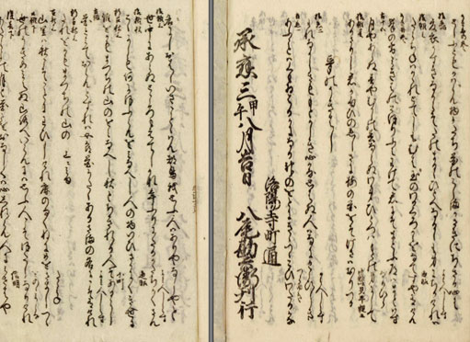
“A page from the 1654 copy of the novel. It looks as though it could be Murasaki's original, handwritten in beautiful characters, on fine paper.” http://www.learner.org/courses/worldlit/the-tale-of-genji/explore/slideshow.html#slideshow_9.

Based on this image, describe the way Japanese is written. Then compare it to how English is written.
____________________________________________________________________________________________________________________________________________________________________________________________________________________________________________________________________________________________________________________________________________________________________________

- “When he reached the age of twelve, he went through his initiation ceremonies and received the cap of an adult. It was held in the Grand Seiryouden Hall. The throne faced east on the east porch, and before it was Genji's seat and that of the minister who was to bestow on him the official cap. The freshness of his face and his boyish coiffure were again such as to make the emperor regret that the change must take place. The secretary of the treasury performed the ritual cutting of the boy’s hair. As the beautiful locks fell the emperor was seized with a hopeless longing for his dead lady. The ceremony over, the boy withdrew to change into adult trousers and descended into the courtyard for ceremonial thanksgiving. The emperor was stirred by the deepest of emotions. He had on brief occasions been able to forget the past, and now it all came back again. Vaguely apprehensive lest the initiation of so young a boy bring a sudden aging, he was astonished to see that his son delighted him even more. Genji married Aoi-no-Ue, the daughter of the Minister of Left. The bride was older, and ill at ease with young husband. Fujitsubo was for him a sublime beauty.” (page 3, paragraphs 2-6)

Describe the ceremonies that took place when Genji was twelve. Explain the significance of these events.
____________________________________________________________________________________________________________________________________________________________________________________________________________________________________________________________________________________________________________________________________________________________________________
- “She was more amiable than the one I have just described to you. Everything about her told of refinement. Her poems, her handwriting when she dashed off a letter, the koto (long Japanese zither) she plucked a note on-- everything seemed right. She was clever with her hands and clever with words… He took out a flute and played a tune on it. Blending nicely with the flute, there came the mellow tones of a Japanese koto.” (page 4, 2nd paragraph)

Based on the text, what characteristics or talents should a women in the court possess?
____________________________________________________________________________________________________________________________________________________________________________________________________________________________________________________________________________________________________________________________________________________________________________

- “The Kamo festival was held on the birthday in the Fourth Month. The older emperor's third daughter, whose mother was Kokiden, replaced the high priestess. Because of this alteration, the processions taking place were grander than usual. Genji was among the attendants. The roads were full of people and vehicles. The Rokujo lady had also come quietly to see the procession. But a latecomer took her place: it was Aoi's carriage. Aoi’s servants had broken the stools for her carriage shafts. She was filled with tears at that insult. On the following day, Genji decided to set out to view the festival with Murasaki. He went to her room in the west wing. Ladies were also preparing for the outing. He found that her hair was too long, so he summoned a doctor to check the Buddhist calendar to confirm whether the day was suitable for a haircut. Then he trimmed her hair himself. She stood on the Go plate to check the length of her hair.” (page 11, paragraphs 1 and 2)

What can you infer about the importance of a women’s hair according to the passage. Explain.
____________________________________________________________________________________________________________________________________________________________________________________________________________________________________________________________________________________________________________________________________________________________________________
- “Borrowing the uncle's cell for fasting and meditation, he stayed for several days. He gathered erudite monks and listened to their discussions. The color of falling leaves was beautiful. He read the sixty Tendai sutras and reflected on what Fujitsubo thought and on himself. When he returned from the temple, even the lowest people came to see him off. Fujitsubo performed the memorial services on the anniversary of the old emperor in November. In the Twelfth Month, she organized the reading of eight scrolls. The reading on the first day was dedicated to her father, the late emperor, on the second to her mother, the empress, and on the third to her husband. The third day was a special day, and the monks read the climactic fifth scroll. Prince Hyobu and Genji made a procession with offerings. On the last day, Fujitusbo announced her intention of becoming a nun, which surprised all of them because of the suddenness…The day of the serpent in the Third Month is a good day to wash away one's worries. He summoned a soothsayer to perform the purification. When he pushed the large doll bearing sins into the river, he could see himself in it. He prayed to heaven proclaiming why a blameless person like me had to be punished. Suddenly the sky turned black and the lightning and a thunderstorm came and would not stop.”(page 11, paragraph 5)

- Explain the religious practices mentioned.
____________________________________________________________________________________________________________________________________________________________________________________________________________________________________________________________________________________________________________________________________________________________________________

- What can you conclude about the importance of family? Explain.
____________________________________________________________________________________________________________________________________________________________________________________________________________________________________________________________________________________________________________________________________________________________________________
- “Taking more than usual care, Genji chose robes for the visit to the Akashi lady in Oi. His trousers were beautifully dyed and scented, and over them he had thrown an informal court robe of white lined with red. Looking after him as he came to say goodbye, his radiance competed with the evening sunlight.”(page 17, paragraphs 3 and 4)

Based on the passage, what was needed for a courtly man to be made presentable?
____________________________________________________________________________________________________________________________________________________________________________________________________________________________________________________________________________________________________________________________________________________________________________

- “There was a heavy fall of snow. In the evening there were new flurries. The moon turned the deepest recesses of the garden into a gleaming white. The contrast between the snow on the bamboo and the snow on the pines was very beautiful. The flowerbeds were wasted, the brook seemed to send up a strangled cry, and the lake was frozen and somehow terrible. Genji sent little maidservants into the garden, telling them that they must make snowmen. They seemed to enjoy themselves, which was all very charming.” (pages 17 and 18).
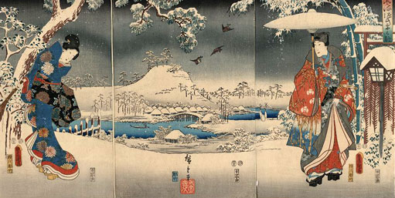
Library of Congress Prints & Photographs Division. http://www.learner.org/courses/worldlit/the-tale-of-genji/explore/slideshow.html#slideshow_2

- What are some uses of imagery are found in the text or painting? List two. Why do you think the author, Murasaki, chooses to use these images?
____________________________________________________________________________________________________________________________________________________________________________________________________________________________________________________________________________________________________________________________________________________________________________

- What can you tell about Genji’s character based on the passage?
____________________________________________________________________________________________________________________________________________________________________________________________________________________________________________________________________________________________________________________________________________________________________________

- “To reply to the Empress Akikonomu, who had sent an ornamental box of arranged autumn leaves and flowers in the last autumn, Murasaki would have liked to answer properly by showing off her spring garden…The dragon and phoenix boats were brilliantly decorated in the Chinese fashion. The professional flutists struck up a melody. The little pages and helmsmen, their hair still bound up, wore Chinese dress. A willow trailed its branches in the deepening green, the cherry blossoms were at their best, the wisteria was rich, and yellow yamabuki reflected on the lakes as if about to join its own image. Waterfowls swam holding twigs in their bills. Genji and some young women watched from the angling pavilion. There was to be a reading of the Prajnaparamita Sutra commissioned by Empress Akikonomu. Murasaki had prepared the floral offerings. She chose eight of her prettiest girls to deliver them, dressing four as birds and four as butterflies. The birds brought cherry blossoms in silver vases, the butterflies brought yamabuki, the yellow flowers, in gold vases. After they handed over the flowers to the monks, the girls started dancing. The music for the dance of the birds rang forth to the singing of warblers, to which the waterfowls on the lake added their clucks and chirps. The butterflies seemed to fly higher than the birds as they disappeared behind a low fence of yamabuki. It was with great regret that the audience saw the dances come to an end.”(page 20, paragraphs 2 and 3)

- In what ways did the Chinese influence the Japanese according to the passage?
____________________________________________________________________________________________________________________________________________________________________________________________________________________________________________________________________________________________________________________________________________________________________________

- Why do you think the audience felt regret when the dances came to an end?
____________________________________________________________________________________________________________________________________________________________________________________________________________________________________________________________________________________________________________________________________________________________________________
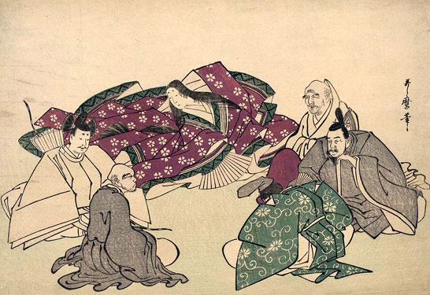
9.
“This Japanese drawing from the 1700s shows the author Murasaki with five wise poets.” Library of Congress Prints & Photographs Division. http://www.learner.org/courses/worldlit/the-tale-of-genji/explore/slideshow.html#slideshow_6

- Analyze this photo. What do you see? Is there anything unusual about this photo? During this time, would you have always seen a women with such a large group of men?
____________________________________________________________________________________________________________________________________________________________________________________________________________________________________________________________________________________________________________________________________________________________________________

- Compare the dress of each of the people. Can you determine anything about their social standings based on their dress? How?
____________________________________________________________________________________________________________________________________________________________________________________________________________________________________________________________________________________________________________________________________________________________________________

Resources

- Nagase, Mari. "The Tale of Genji."UNESCO. UNESCO, 1 Jan. 2000. Web. 1 Mar. 2015. <http://webworld.unesco.org/genji/en/away.pd
- "The Tale of Genji." / The Tale of Genji / Invitation to World Literature. Annenberg Foundation, 1 Jan. 2013. Web. 1 Mar. 2015. <http://www.learner.org/courses/worldlit/the-tale-of-genji/explore/>.

